**My Complaint is:- Planning Scheme Policy Breach**

If the City of Moreton Bay officially adopts and publishes a Planning Scheme Policy, then how is it legitimate to approve a development application that markedly does not conform to the adopted policy?

The approval given to DA 2024/4695 by a Delegated Officer in the Planning Dept was an egregious breach of the adopted Planning Policy.

The approval needs to be withdrawn forthwith, as the Planning Department has failed to adopt and apply the Council’s Adopted Planning Policy.

The failure to comply with the Planning Policy turns on the Section 3 of the Planning Scheme Policy (PSP) - Residential Design.

The PSP - Residential Design states in its opening sentence that:-

“Moreton Bay Regional Council adopted this planning scheme policy on 24 November 2015.”

Section 1.4 of the PSP-Resdiential design states (emphasis added):-

This **planning scheme policy** is intended **to be used** by developers and designers, **development assessment planners** and building professionals.

How can the Council Planning Officers ignore the Policy which meticulously shows that a seven storey high-rise building is not to be approved, as has been done in the matter of DA/2024/4695.

The opening paragraph for the Section 3 of the adopted Planning Scheme Policy- Residential Design, states it uses "typologies" to set out the various dwelling options available. Then the section 3.2.1 does the work of fully describing the range of typologies available for each circumstance, based upon precinct, road type and property frontage.

The target footprint for the DA/2024/4695 is a property of 554 square metres, with a street frontage of 21.5m.

The Typology 8 is set as the upper range of typologies available for the site as shown in the adopted Planning Scheme Policy- Residential Design. A Typology of 8 signifies a low-rise apartment building of 2 to 3 levels. The approved Development Application is for a high-rise 7 storey apartment building. That would equate to the Typology 10.

The adopted Planning Policy Instrument unquestionably states that the available typologies for the lot the subject of DA/2024/4695 can be only:-

0: Dwelling House (Traditional)

3: Dwelling Unit

6: Multiple Dwelling (Plexes)

7: Multiple Dwelling (Terrace or Row House)

8: Multiple Dwelling (Low Rise Apartment)

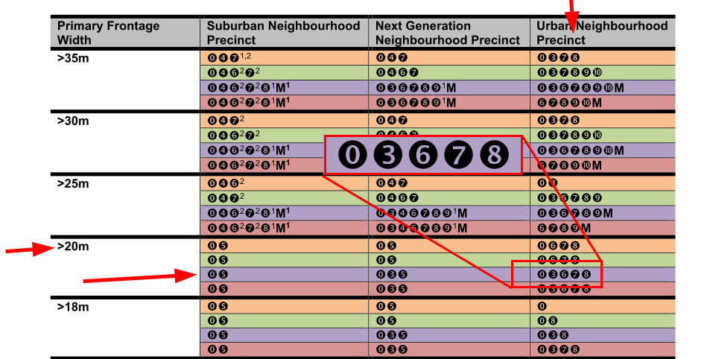

A Low Rise Apartment is further described as an up-to 3 level building. A seven storey high rise apartment is not in the scope of what is allowed in terms of the adopted Planning Policy. Council must rescind the approval.

For a Planning Officer to issue an approval that completely disregards the adopted Policy is a serious matter. **The only appropriate resolution for the Council Administration is to rescind the approval.** Unless this is done, the Council is in breach of the QLD Planning Act 2016.

If the Council then incurs some financial impost, then blame can only be attributed to the system where there has been delegated authority with lack of oversight.

The DA/2024/4695 approval is corrupt morally and ethically.

In the approval, it is demonstrably untrue to state that the proposal “Is of a scale, density and design that respects the character of the zone, precinct and streetscape”.

The proposal **did not and does not comply** with the PSP- Residential Design section 3. The Section 3 clearly sets out the range of typologies available based upon several metrics.

The Delegated Approval must be rescinded by the Council Executive for the Council to maintain its integrity.