### City of Moreton Bay/Moreton Bay Regional Council Governance Complaint

**Basic Complaint**

Despite several warnings given to the City of Moreton Bay by neighbours in the period commencing October 2024, the Planning Department for the Council has granted an approval for a high rise building on a property immediately adjacent to where I live. The proposed building would negatively impact my environment and that of my neighbours. The approval is in direct contravention of the Council’s adopted planning policy.

**The Planning Policy**

The Council has a comprehensive Planning Policy in place. The Planning Policy is made up of several published Planning Documents/Planning Instruments. The main document I wish to highlight is the Planning Scheme Policy - Residential Design (PSP-Residential Design).

The opening statement (1.1) within the PSP-Residential Design is:-

“Moreton Bay Regional Council adopted this planning scheme policy on 24 November 2015.”

Then in Section 1.4 it shows:-

1.4 Who should use the Residential design PSP

This planning scheme policy is intended to be used by developers and designers, development assessment planners and building professionals.

There can be no argument that the PSP-Residential Design is not an integral component of the Council’s Planning Scheme Policy. The Planning Scheme Policy has many such PSP documents detailing aspects of Policy.

In particular, I am concerned with the breach of the Section 3 of the PSP-Residential Design in relation to a now approved Development Application DA/2024/4695 the Council had for consideration. The DA/2024/4695 was for a seven storey high rise apartment building. Delegated Approval was given on 26/March/2025.

The failure to comply with the Planning Policy turns on the Section 3 of the adopted Planning Scheme Policy (PSP) - Residential Design.

The opening paragraph for the Section 3 of the adopted Planning Scheme Policy- Residential Design, states it uses "typologies" to set out the various dwelling options available. Then the section 3.2.1 does the work of fully describing the range of typologies available for each circumstance, based upon precinct, road type and property frontage.

The target footprint for the DA/2024/4695 is a property of 554 square metres, with a street frontage of 21.5m.

The Typology 8 is set as the upper range of typologies available for the target site as shown in the adopted Planning Scheme Policy- Residential Design.  
A Typology of 8 signifies a low-rise apartment building of 2 to 3 levels. The approved Development Application is for a high-rise 7 storey apartment building. That would equate to the Typology 10.

The adopted Planning Policy Instrument unquestionably states that the available typologies for the lot the subject of DA/2024/4695 can be only:-

0: Dwelling House (Traditional)

3: Dwelling Unit

6: Multiple Dwelling (Plexes)

7: Multiple Dwelling (Terrace or Row House)

8: Multiple Dwelling (Low Rise Apartment)

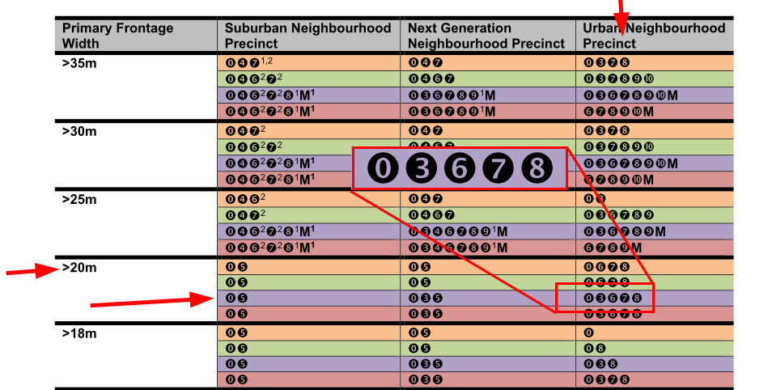

A Low Rise Apartment is further described as an up-to 3 level building. A seven storey high rise apartment is not in the scope of what is allowed in terms of the adopted Planning Policy.

**Due Diligence**

Before purchasing Units within the building where I live, several neighbours conducted due diligence on what might be approved for the adjacent Lot. Until April 2024, the Lot was occupied by a dilapidated house. Due diligence investigation showed that Council might approve an up-to three level building for the Lot based on the Planning Scheme Policy documents.

**Actions Taken**

Upon learning that an application for material change of use for the Lot was lodged in October 2024, and noting that the application was for a structure far exceeding the published Planning Scheme Policy, many neighbours began alerting the Council to the conflict with Policy.

Attempts were madeto have the Application classified as Impact Assessable in lieu it being seen as Code Assessable. Those attempts failed to have the assessment level changed from Code to Impact despite the loose assessment of criteria that used the wording “generally”. Some assessment examples were:-

“generally in accordance with Council’s policies.”

“parking spaces generally not visible from the street. “

“in accordance with Council’s requirements, generally as shown on the plans.”

It appears our concerns and reports of the non-compliant development application fell on deaf ears and we were ignored at all levels within Council as Council approved the DA/2024/4695 on 26/March/2025.

**Policy Defined**

The Cambridge Dictionary defines “policy” as (emphasis added):

“A set of ideas or a plan of what to do in particular situations that has been agreed to officially by a group of people, a business organization, a government, or a political party.”

It is expected that neither the Council Planning department, nor any other Council department would act outside Policy.

**Normalisation of Deviance**

There is a growing culture of normalisation of deviance within the Council. This comes about due to the acceptance of earlier slightly non-conforming applications that ignore or deviate from Policy. This leads to the gradual change of culture of it then appearing okay to approve subsequent non-conforming but different projects.

The full Council has adopted the Planning Scheme Policy documents, but it is evident that their Planning Department, using their Delegated Authority, do not always conform with the adopted policy. Accepting statements such as a parameter “generally conforms” or “generally in accordance with” has become the norm. There has been failed oversight by the Council Executive of the Delegated Authority. This is also part of the culture of the normalisation of deviance that has infected the Council.

**In Summary**

The adoption and publication of a Planning Scheme Policy sets up a contract with society and ratepayers. To allow the approval of DA/2024/4695 to stand breaks that contract.

Policy is Policy. As shown above policy is defined as having been officially agreed to by a group of people, and governments.

The normalisation of deviance within the Council must be recognised and halted.

The Planning Department officers seem unduly ready and keen to accede to applications presented from some town planning companies.

The DA/2024/4695 approval is corrupt morally and ethically.

In the approval, it is demonstrably untrue to state that the proposal “Is of a scale, density and design that respects the character of the zone, precinct and streetscape”.

The proposal **did not** and **does not comply** with the PSP- Residential Design section 3. The Section 3 clearly sets out the range of typologies available based upon several metrics. The Delegated Approval conveniently omits mention of the non-compliance.

The Delegated Approval also breaches other metrics in connection with adopted policy concerning Waste collection, and Service Vehicle requirements.

**Desired Outcome**

Now that the Planning Department has misused their Delegated Authority to give approval to DA/2024/4695, the desired outcome is that the Council Executive rescind that Delegated Approval as it was not in accord with the adopted policy.

*YourNameHere*